Ex.1 - PART B - I.D. (212641229, 211803234)

PART B

Part 1:

If we were to calculate only one measure, we would choose the median. According to the histogram, it is easy to see that there are some outliers, such as the “jump” in the counts of the early “cnt feature”. As we have learned, the median is more robust than the mean to outliers, so it would be wiser to choose it.

Part 2:

1. **The relation between the temperature and the number of bicycles rented in winter holiday:**

To better observate the correlation between the temperature and the number of bicycles rented at holiday winters we used a variant of WMA (Weighted Moving Average).

As clearly visible, the temperature, as given (unlike real life) is not continuous, thus making it hard to spot the correlation. With the WMA in mind, we attempted to reduce the noise, caused by the non-continuity.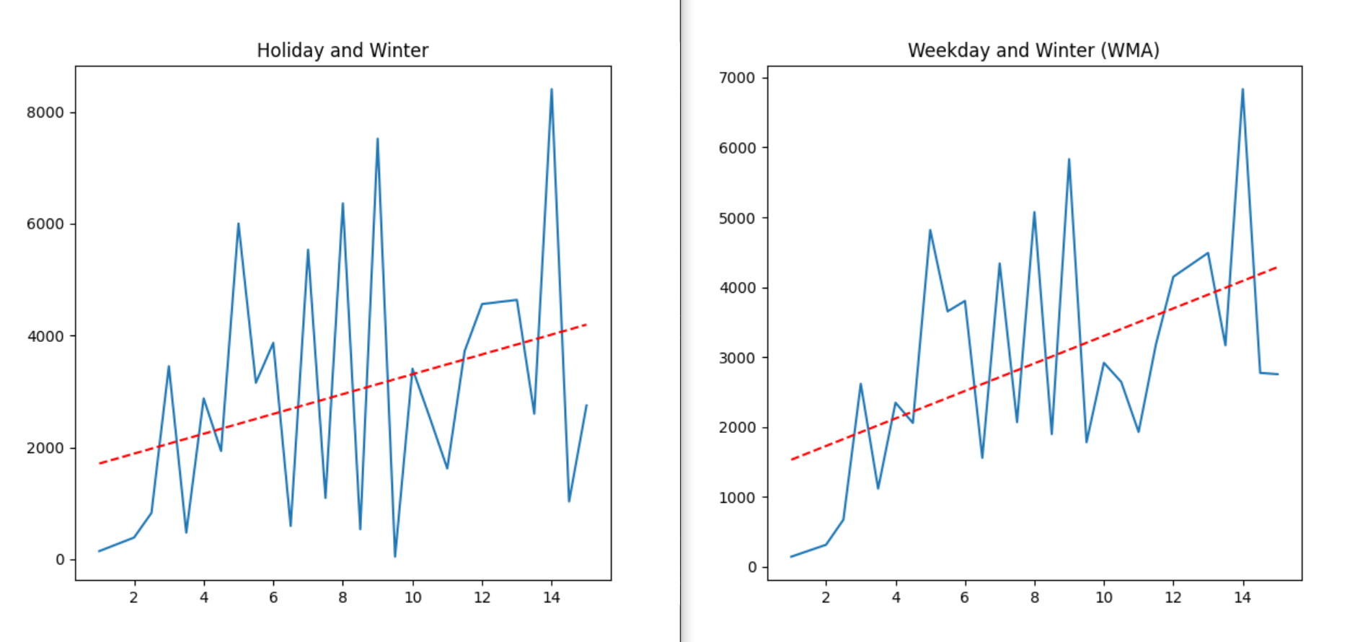

Clearly, there is a positive correlation between the temperature and the number of bicycles rented. This correlation is better seen in the WMA results.

1. **The relation between the temperature and the number of bicycles rented in winter weekdays:**  As we can see in the graph and the trend polynomial below, there is a distinct correlation between the number of rented bicycles in winter weekdays and the temperature in these days. There are more bicycles rented when the temperature is neither hot nor cold- around 7-8 degrees. If the temperature is greater or lesser than 7-8 degrees, the number of rented goes down in an almost-parabolic way.